**Master Schedule**  
  
A master schedule represents a summary of the projects schedule which identifies all the deliverables for the project as well as all individual components which need to be completed along with the date of completion; allowing a project to provide all deliverables on time. This project endorses the use of GANTT charts. A Gantt chart displays tasks against time, which are represented using a bar per task. The position and length of a bar reflect the duration, start and end date of the task. The combination of the bars in the Gantt chart allows a member to see what tasks there are, the start and end date of the tasks, as well as the duration. The member can also see where activities overlap with each other and can see the whole duration of the project schedule. This project was subject to change, resulting in alterations to the master schedule.

The initial Gantt chart (figure 1) provided a good timescale, scheduling all the deliverables before the project’s deadline. However, it was required to be altered due to unforeseen actions. The time scales became inaccurate due to changes and prioritization of the project. The duration of tasks was inaccurate as members were doing task quickly or the allocated time was too short on feedback given by the members. The unforeseen action of changing the model in week four of the schedule provided a delay in schedule and disrupted the course of the project. Alterations were made to produce an up-to-date master schedule that took account of the feedback given on the duration of the tasks.

The second iteration (figure 2) of the master schedule provided more accurate estimations of the tasks and included the disruption of week four within. The future tasks were altered in their duration due to the description to ensure that all the projects’ deliverables were able to be completed by the end of the project’s timeframe.

The final iteration (week 8) addressed team members concerns for the tasks and their duration for the iterative development tasks. The task order in the previous iteration wasn’t in a logical order nor had an accurate duration allocated to them. The order of tasks was changed from model evaluation, pipeline evaluation, parameter justification and reproducible code to reproducible code, pipeline evaluation, parameter justification to model evaluation, as seen in figure 3.

**References**

*Master Schedule* (no date) Available at:<https://project-management-knowledge.com/definitions/m/master-schedule/#:~:text=This%20master%20schedule%20represents%20a,are%20all%20unique%20schedule%20milestones>. (Accessed: 01/05/25)

*What is a Gantt Chart?* (no date) Available at: <https://www.gantt.com/> (Accessed: 01/05/25)

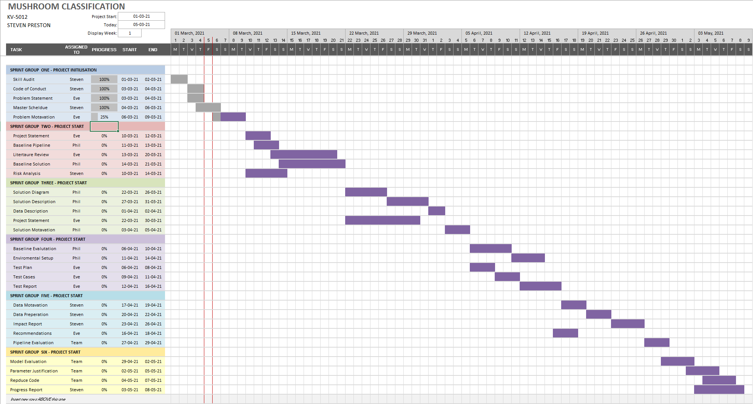Figure 1: First Iteration of the master schedule for the mushroom classification project.

Figure 2: Second Iteration of the master schedule for the mushroom classification project.

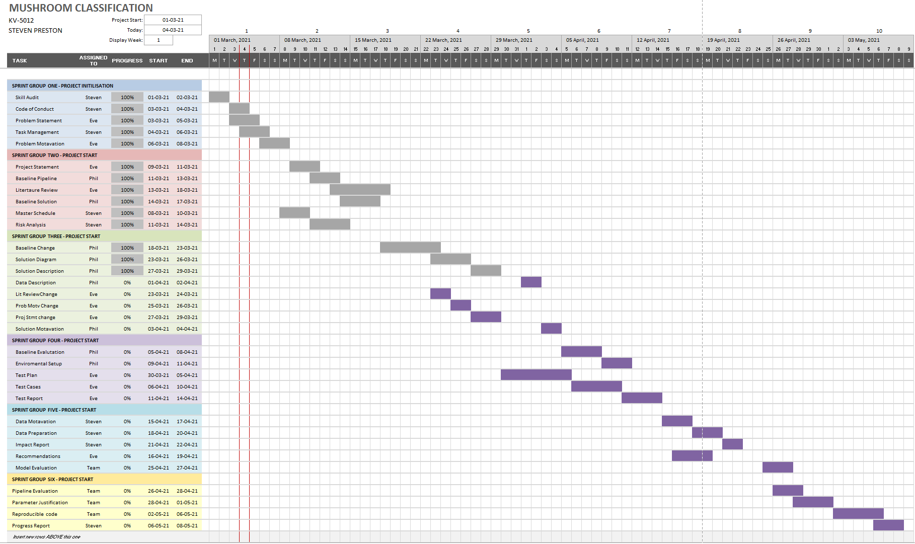

Figure 3: Final Iteration of the master schedule for the mushroom classification project.

